Diary of Quarantine

Name:
Class group:

WEEK 4: April 14th- 17th
Activity 1:

Review the present simple. Go to Isabelperez.com, The Happy Verby Gang, Present Simple Girl and read the form and uses. Do a summary and then, choose 3 different activities to do and copy them activities in your diary.

Ve a Isabelperez.com, The Happy Verby Gang, Present Simple Girl y lee la forma y los usos. Haz un resumen de esto y después, elige 3 actividades diferentes para hacer y copiarlas aquí en tu diario.

(2 points)

Summary:

Form | Affirmative:  Negative:  Interrogative:
Uses | *  *  *
Activity 1
Activity 2
Activity 3

Activity 2:

Talk about your daily routines during this quarantine.

Habla de tus rutinas durante esta cuarentena.

(2 points)

In the morning...
In the afternoon...
In the evening...

Activity 3:

Now give ideas about things to do at home… doing your homework, helping with housework, or other activities such as sports, cooking, arts and crafts, entertainment (movies, books, video games,...) Choose at least three examples and describe them.

Ahora da ideas sobre cosas para hacer en casa… hacer deberes, ayudar con las tareas domésticas, u otras actividades como deporte, cocinar, manualidades, entretenimiento (películas, libros, videojuegos…) Elige al menos tres ejemplos y descríbelos.

(2 points)

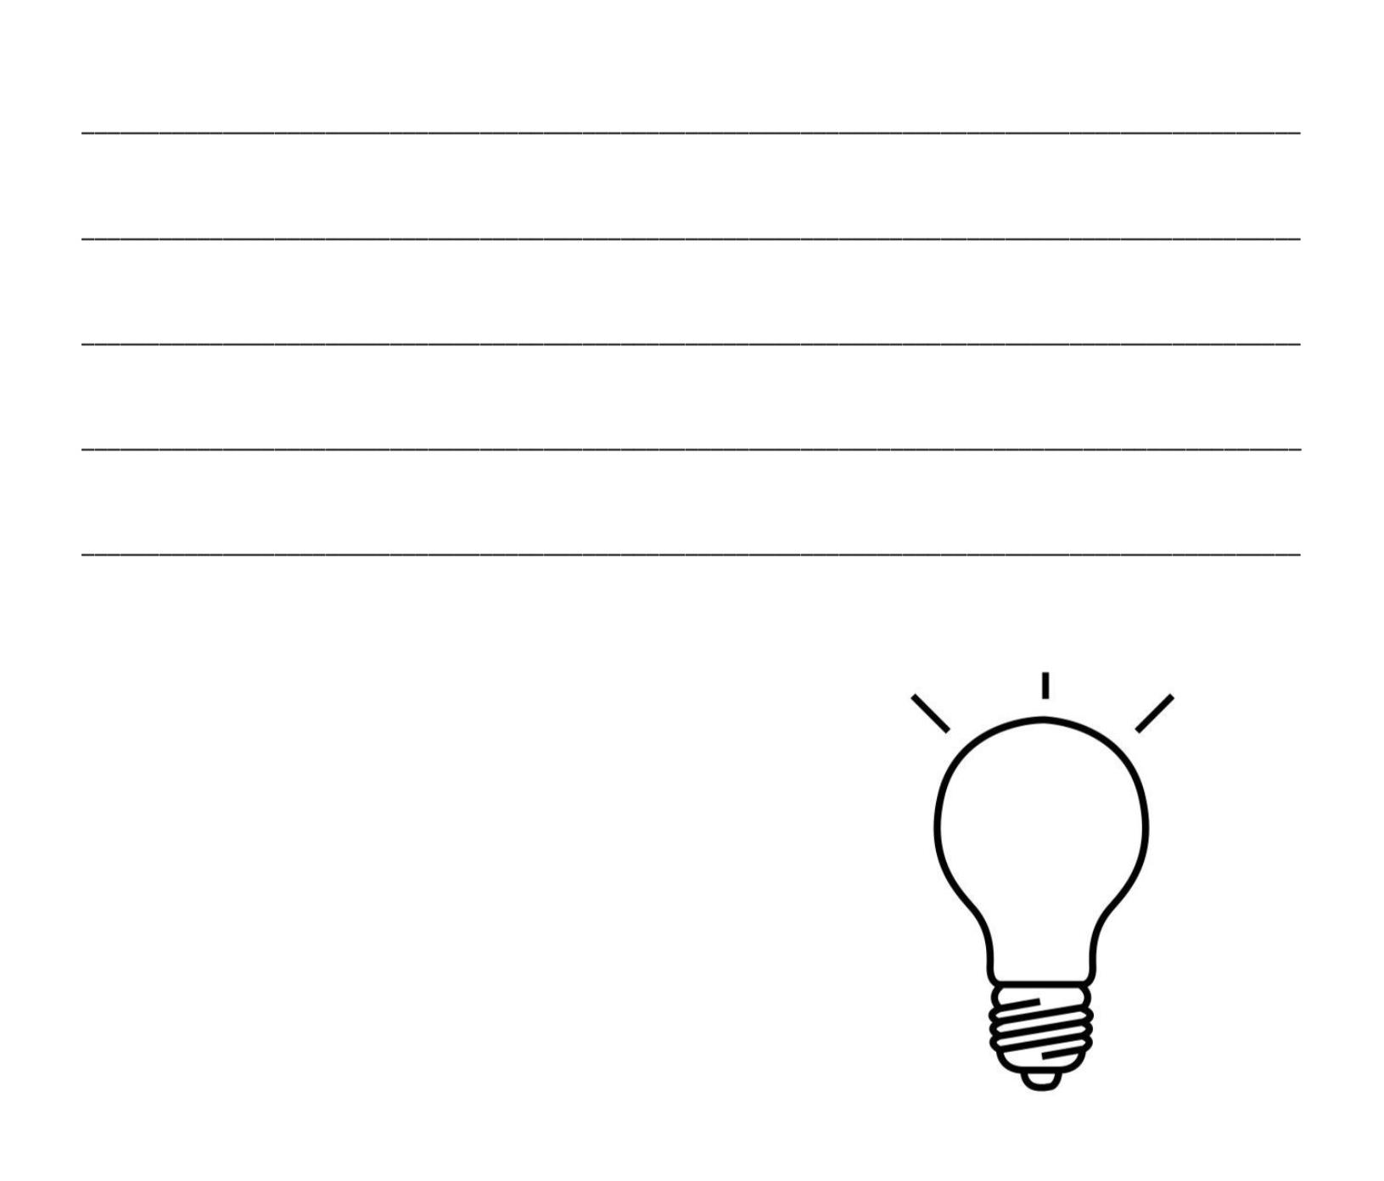

Activity 4:

Complete these sentences

(2 points)

❤️ My favourite time of the day is…

The best moment during this week was…

Most of the time I feel...

Activity 5:

(2 points)

Now, put a picture of the people you are living with during these days.

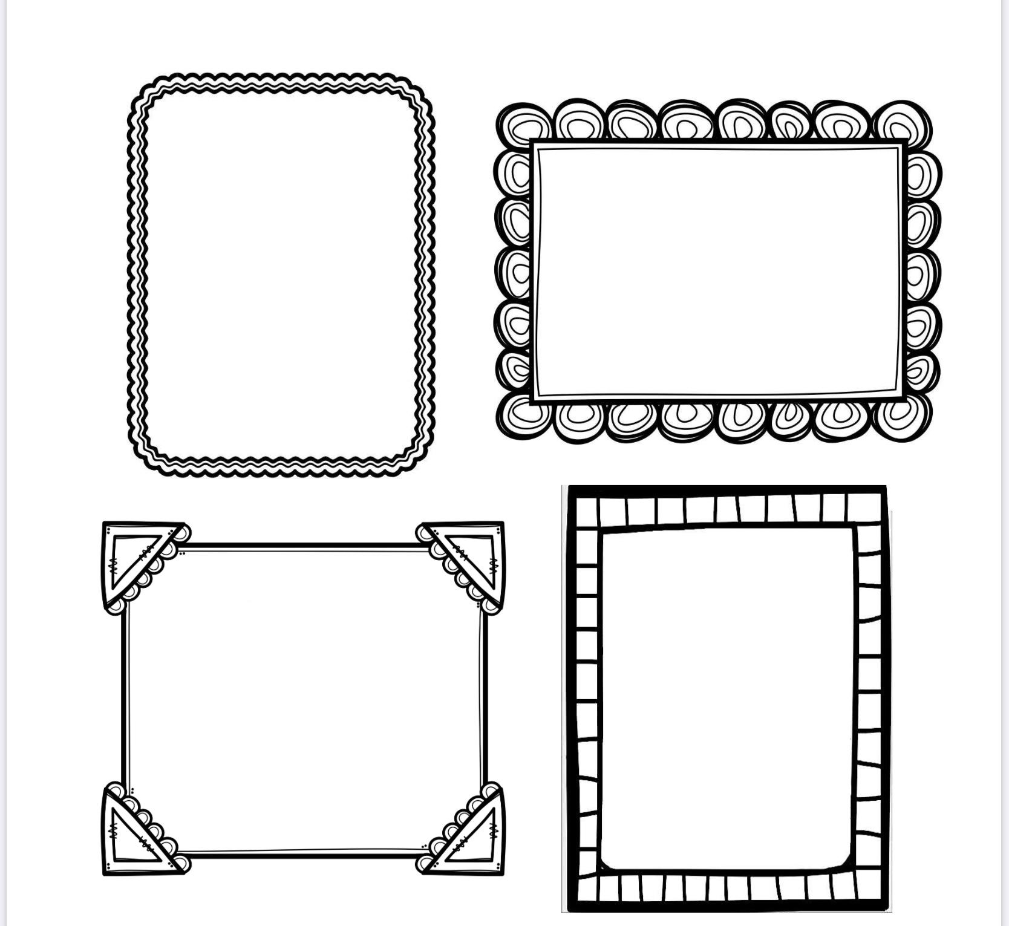

Do you miss someone? Put a picture of those people you think about during this quarantine period.
